Image | 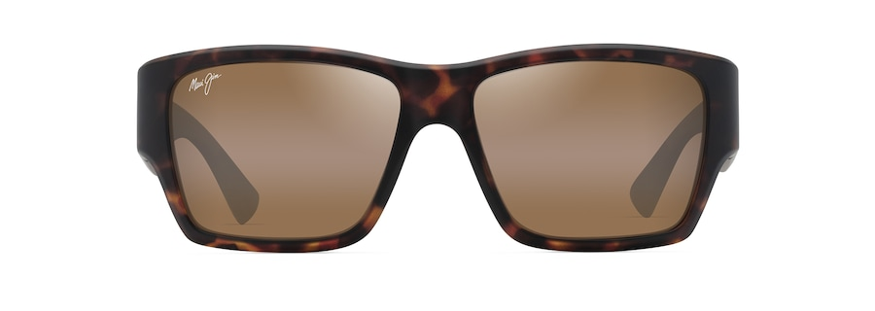
Brand | MAUI JIM
Model Name | KA‘OLU
Price | RS 2999
PRODUCT DETAILS

